Sermon on Sunday 27 September
by Geoff Oates, Lay Reader
Creationtide Week 4 – The Gift of Water
(Readings: Exodus 17. 1-7; John 4. 5-15)
John 4. 7: ‘Give me a drink of water’
There is something profoundly existential about this scene. To those of us who are blessed to live in a land that has perhaps a little more rainfall that we would like, it can be hard to understand what it is like to live in a hot land where water is scarce.
A woman walks through the noonday heat to get water from a well. A woman’s job then – as it still is now for the 800 million or so people in today’s world who have to walk long distances with their pots and canisters to the nearest well, or muddy stream, or the communal stand pipe in the middle of a shanty town.
A stranger, a foreigner, accosts her with the simplest, yet most vital, plea: ‘Give me a drink of water’.
Three words you won’t find in the Bible: ‘God created water’. In the very first verses of the book of Genesis, before God speaks his first words of creation, there are two things already present. The spirit of God, hovering over the water.
Our natural historians confirm the wisdom of the ancient storytellers – life began with water.
But when the old story tells us that God made man from the clay of the earth and breathed life into him, they forgot to mention that He also mixed in two parts water. Water contributes 65% of our body mass – and 75% of our brains.
From the water wheels of ancient mills to the vast turbines of hydro-electric power stations, we have known how to turn the force of water to humanity’s benefit – but it goes further than that: our very thoughts are water–powered.
No wonder that the ancient people of Israel saw flowing water as the perfect metaphor for the life-giving grace and power of their God.
We have just heard an ancient story from the book of Exodus. Moses leads the Hebrews through the desert of Sinai on their flight from slavery in Egypt. The thirsting people begin to lose faith, and demand water. Moses prays to God, then strikes a desert rock with his staff, and water flows forth. Mankind asks for the gift of water, and God provides.
We have heard the story of the Samaritan woman at the well. But this time it is not the human asking God for water. It is God who asks the woman, ‘Give me a drink of water’.
Typically for John’s Gospel, this story is wrapped in profound theology about the growing distance between the new Christian faith and its Jewish roots, but I want to leave that to one side today and go back to two figures meeting at the well.
In so many ways this meeting should not take place. A respectable Jewish man has no business speaking to an unaccompanied woman he does not know. A respectable woman certainly has no business answering him.
She’s also a Samaritan. Samaritans and Jews didn’t get on. They didn’t mix, especially when it came to food and drink. What does Jesus think he is doing, asking to share her water, disregarding the social distancing rules that have applied for centuries. Surely the woman will say no! What else can he expect? Jesus risks making an utter fool of himself.
There are so many walls of convention, pride, fear and prejudice to be overcome before there can be any meaningful meeting between these two figures. How can the walls be broken down?
By going to the woman with his simplest, deepest need. A drink of water in the noonday heat. He needs her help. Real help. The well is deep, and water is heavy to lift. He hasn’t got a bucket. She has.
Ironically, it’s never quite clear whether Jesus gets his drink of water, but after a rather dismissive first response, the woman lays aside her own fears and prejudices, and allows something of God’s grace to flow into her life.
How often does that channel of grace open up, not when we ask for something of God, but when God asks for something from us?
We may not always recognise the voice of God, for His face and voice blend naturally into the crowd amongst the most ordinary of his children. Many that He asks, just like the Samaritan woman, would be honestly surprised to be invited to serve Him. He doesn’t just ask ‘Churchy’ people.
But He constantly calls and prompts all of us: to take the first step to end a family feud or restore a workplace relationship; to offer help and companionship to a struggling or lonely neighbour; even to give water to the thirsty. To help some of those 800 million people who face an exhausting daily struggle for clean, safe water.
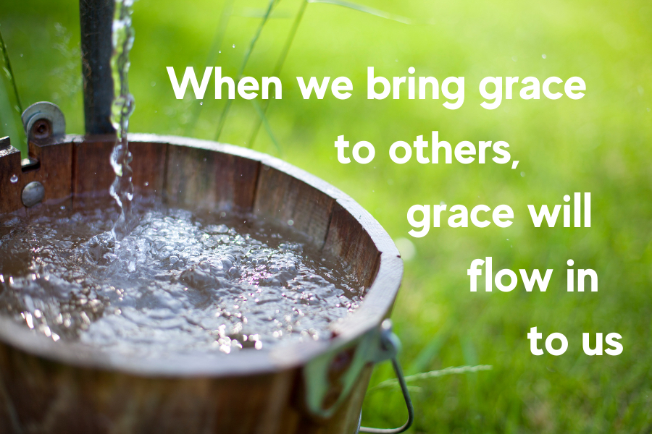
When we bring grace to others, grace will flow in to us. When you did physics at school, did you do the experiment to show how a syphon works? A bucket of water on the desk, a rubber tube going down into an empty bucket on the floor.
Nothing happens. The water cannot flow up over the edge of the top bucket. Health and safety would probably not permit it now, but a volunteer would get the task of sucking the water through the tube until it started to flow down. And then it just kept on flowing.
God is looking for volunteers to get the water flowing! If we can get it started, he will look after the rest.
God doesn’t carry a bucket in our world. He needs to borrow ours. Have you got a bucket? There are a lot of thirsty people out there.
Amen

